**Excel Assignment – 8**

**1. What do you mean by AutoComplete feature in Excel and what are the**

**benefits of using this feature?**

AutoComplete is the automatic filling in of your text when you start typing and is switched on by default. This will reduce the amount of text you have to enter by preventing you typing in repetitive words. AutoComplete matches only exact cell entries, not individual words in a cell. This does not work when entering or editing formulas.

AutoComplete helps you quickly insert functions and arguments while minimizing typing and syntax errors. The AutoComplete menu shows you available options based on context, and you choose what you want to insert into your formula.

Autofill covers anything from dates, days of the week, to months of the year and more…Excel will **automatically fill in the series**.  this can save so much time and reduce data entry errors.

**2. Explain working with workbooks and working with cells.**

**Working with workbooks**

A collection of worksheets is referred to as a workbook (spreadsheets). Workbooks are your Excel files. You’ll need to create a new workbook every time you start a new project in Excel. There are various ways to begin working with an Excel workbook. You can either start from scratch or use a pre-designed template to create a new workbook or access an existing one.

**Working with cells**

Cells are small **rectangular boxes in the worksheet where we enter data**. A cell is the intersection of a row and column. It is identified by row number and column header. In Excel, each cell is identified using a set of coordinates or positions, such as A1 (where A represents a column and 1 represents the row), B2, or M16.

You can perform several operations with cells in Excel, unlike changing the font style, font size, background color, text alignment, format painter, wrap text, and conditional formatting.

Excel provides the feature to select **multiple cells** at one time. A group of selected cells is collectively known as **cell range**. With cell range instead of a single cell address, the user refers to a cell range utilizing the cell addresses of the selected **first** and **last** cells, separated by a **colon**. For instance, a cell range covering B2, B3, B4, B5, B6, B7, B8, B9, and B10 would be addressed as **B1:B10**.

**3. What is fill handle in Excel and why do we use it?**

Excel's fill handle is a small rectangular control that appears whenever a cell or range of cells are selected. When the cursor is moved over the fill handle, it turns into a cross symbol, which can be dragged to fill in more cells.

The behavior of the fill handle varies depending on the content of the cell or range selected:

1. When the selected range contains formulas, the formulas are copied to new locations and references are updated.
2. When the selected range contains text or numbers with no recognizable pattern, values are copied.
3. When the selected range contains text or numbers with a recognizable pattern, the pattern is continued.

**4. Give some examples of using the fill handle.**

**Use Fill Handle to Autofill the Number Series Pattern Using Drag and Drop.**

1. First, enter the value in a cell from which you want to start the series and click and hold the Fill Handle and drag up to the cell to which you want to copy the series.
2. After that, click and open the Fill Handle icon and select the “Fill Series” option and your list will be converted to a series with increments by 1.

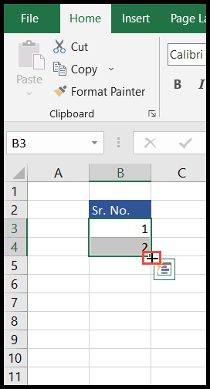

3. Or enter the value in at least two cells to create a pattern to be followed by Fill Handle.

4. After that, select both the cells and place the mouse cursor over the bottom right corner of the cell and a plus (+) sign icon (Fill Handle) will appear.

5. Now, click and hold the mouse button and drag to the cell up to which you want to auto-fill the pattern.

**5. Describe flash fill and what the different ways to access the flash fill are.**

*Excel Flash Fill* is a special tool that analyzes the information you are entering and automatically fills data when it identifies a pattern.

In Excel 2013 and later, the Flash Fill tool resides on the *Data tab*, in the *Data tools* group:  
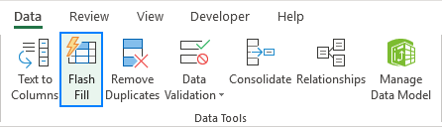

Excel Flash Fill shortcut

Those of you who prefer working from a keyboard most of the time, can run Flash Fill with this key combination: Ctrl + E.

**6. Extract first name and last name from the mail id and then from the address column, extract the city, state, and pin code using the flash fill. Given below is an example of the columns you have to create. Paste the screenshot of what you have created using the flash fill command.**

